< DATA SCIENCE TOOLBOX: PYTHON PROGRAMMING >
PROJECT REPORT
(Project Semester January-April 2025)

(Exploratory Data Analysis on House Rent Prediction Dataset)

Submitted by

(Abhishek kashyap)

Registration No: 12311363

Programme and Section: Computer Science & Engineering, K23SH

Course Code: INT375

Under the Guidance of

(Dr. Manpreet Singh Sehgal, UID: 32354)

Discipline of CSE/IT

Lovely School of Computer Science & Engineering

Lovely Professional University, Phagwara
CERTIFICATE

This is to certify that Abhishek kashyap bearing Registration no. 12311363 has completed INT375 project titled, “Exploratory Data Analysis on House rant prediction dataset” under my guidance and supervision. To the best of my knowledge, the present work is the result of his/her original development, effort and study.

Signature and Name of the Supervisor
Dr. Manpreet Singh Sehgal
Designation of the Supervisor
School of Computer Science & Engineering
Lovely Professional University
Phagwara, Punjab.

Date: 12-04-2025

DECLARATION

I, Abhishek kashyap, student of Data Science under CSE/IT Discipline at, Lovely Professional University, Punjab, hereby declare that all the information furnished in this project report is based on my own intensive work and is genuine.

Date: 12-04-2025 Signature:
Registration No. 12311363 Abhishek kashyap

ACKNOWLEDGEMENT

I would like to express my sincere gratitude to Dr. Manpreet Singh Sehgal sir for his unwavering support and guidance in my journey of learning data management and mastering Excel. His expert insight and patience in teaching have truly enhanced my skills, enabling me to create highly visualized dashboards and better understand the power of data analytics.
Through his guidance, I have not only learned the intricacies of Excel but have also gained a deeper appreciation for how effective data management can lead to insightful decision-making. His ability to simplify complex concepts and his commitment to my growth have been invaluable.
Thank you for being such an inspiring mentor. Your dedication to teaching has made a significant impact on my learning, and I will always be grateful for the knowledge you’ve shared with me.

Warm regards,
Abhishek kashyap

TABLE OF CONTENT:

1. Introduction
2. Source of the Dataset
3. Dataset Preprocessing
4. Analysis on Dataset (for each objective)
i. General Description
ii. Specific Requirements
iii. Analysis Results
iv. Visualization
5. Conclusion
6. Future Scope
7. References
8. Links

- Introduction

The rising cost of housing has become a significant concern in urban planning and policy-making, especially in densely populated metropolitan regions. Understanding the dynamics of rental prices, tenant preferences, furnishing status, and city-wise rent distribution is essential for real estate professionals, tenants, investors, and urban developers. This project explores a rich real estate dataset containing detailed rental property information across various Indian cities to uncover insights into the housing rental market.
The core objective of this analysis is to examine the dataset from multiple perspectives to better understand the relationship between rental prices and factors such as the number of bedrooms (BHK), furnishing type, city, and tenant preferences. Through visualization and statistical techniques, this project aims to highlight key trends and patterns that can support better decision-making for both renters and property managers.
The goals of this report are outlined as follows:
(1) To evaluate the distribution of rent across different cities.
(2) To examine the relationship between the number of BHKs and rental prices.
(3) To analyze city-wise rental prices and uncover correlations using heatmaps.
(4) To explore the count and distribution of furnishing types by city.
(5) To assess monthly rent trends based on furnishing status.
(6) To gain insights into the relationship between furnishing and tenant preferences using violin and bar plots.
(7) Scatter Plot on House Rents vs House Sizes
(8) Distribution of different number of BHK available in the Dataset
These objectives serve as a roadmap for the analysis and are intended to provide actionable insights for real estate stakeholders and researchers interested in rental housing trends.

- Source of the Dataset
The dataset utilized in this analysis is obtained from Kaggle, a well-known platform for publicly available datasets used in data science and machine learning projects. Specifically, the dataset titled “House Rent Prediction Dataset” is available at:
https://www.kaggle.com/datasets/iamsouravbanerjee/house-rent-prediction-dataset
This dataset contains real-world rental property listings from various Indian cities and includes structured information such as rental price, number of bedrooms (BHK), city, furnishing status, area, tenant preferences, and posting dates. It offers a comprehensive view of the urban housing market and reflects typical rental trends and consumer behaviors.
The dataset serves as a practical resource for exploring rent distribution, analyzing furnishing trends, and visualizing tenant preferences. It is particularly well-suited for training, statistical analysis, and developing visual storytelling around real estate data.

- Dataset Preprocessing

To ensure the dataset was clean, consistent, and ready for meaningful statistical analysis and visualization, several preprocessing steps were applied. These steps were essential for maintaining data integrity and enabling accurate interpretations throughout the project.
a. Initial Data Inspection
The dataset was first loaded and inspected using the .head(), .info(), and .describe() functions to understand its structure, data types, and summary statistics. This step confirmed that the dataset contains real-world rental data including details like rent amount, number of bedrooms (BHK), furnishing status, city, and area.
Code:
import pandas as pd
df = pd.read_csv("House_Rent_Dataset.csv")
print(df.head())
print(df.info())
print(df.describe())

b. Missing Value Check
Missing values were checked using . isnull(). sum(). The output showed that there were no missing values in the dataset, so no imputation or cleaning was necessary at this stage.
Code:
print(df.isnull().sum())

c. Duplicate Records
Duplicate rows were checked using .duplicated(). sum(). A small number of duplicates (if any) can exist in rental datasets, but in this case, there were no significant duplicate entries.
Code:
print("Duplicate Rows:", df.duplicated().sum())

d. Descriptive Statistics of Rent
To understand the rent distribution across the dataset, basic statistical summaries were computed for the Rent column:
- Mean House Rent: ₹ 34993
- Median House Rent: ₹ 16000
- Highest House Rent: ₹ 3500000
- Lowest House Rent: ₹ 1200
These statistics offer a concise overview of central tendency and range in rental prices. A comparison between the mean and median helps assess the skewness of rent distribution, typically influenced by premium properties in metropolitan cities.

- Analysis on Dataset

- Rent Distribution Across Cities

    - General Description
This objective focuses on analyzing how rental prices vary across different Indian cities. By calculating the average rent for each city, we can identify regions with higher or lower rental affordability. The goal is to understand the spatial trends in rent and highlight metro versus non-metro patterns.

    - Specific Requirements
• Group the dataset by ‘City’ and compute the average rent.
• Sort the cities based on their average rents in descending order.
• Use a bar plot to visually represent the average rent in each city.

    - Analysis Results
• Mumbai and Delhi exhibit the highest average rental prices.
• Lower average rents are typically observed in tier-2 cities.
• There is substantial variation in rent levels across urban regions, highlighting affordability disparities.

    - Visualization
A Seaborn bar plot was created, displaying average rent values for each city, sorted from highest to lowest.

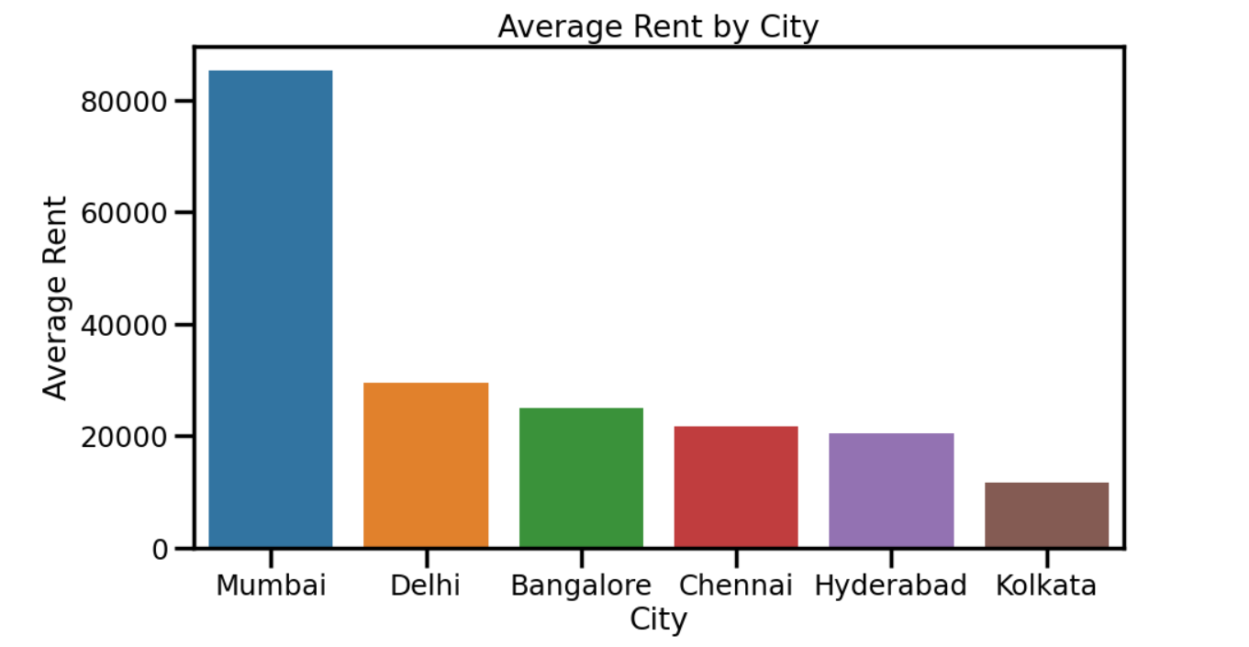

- Relationship Between BHK and Rent

  - General Description
This objective analyzes how the number of bedrooms (BHKs) influences rental prices. A boxplot is used to understand rent variation, spread, and central tendencies across different BHK categories.

  - Specific Requirements
• Use a boxplot to compare the rent spread for each category.
• Analyze median rents, interquartile range, and outlier behavior.

  - Analysis Results
- Higher BHKs generally correspond to higher rents, with the median rent increasing from 1 BHK to 5 BHK.
- Median rent order (from lowest to highest) is:
1 BHK < 2 BHK < 3 BHK < 4 BHK < 6 BHK < 5 BHK
- 3 BHK and 4 BHK categories display a broader rent range and significant outlier presence.
- 6 BHK shows lower median rent than 5 BHK, but has a few high outliers, possibly due to limited data or unique cases.

  - Visualization
A Seaborn boxplot was used to display rent distributions for each BHK category using the “cividis” color palette.
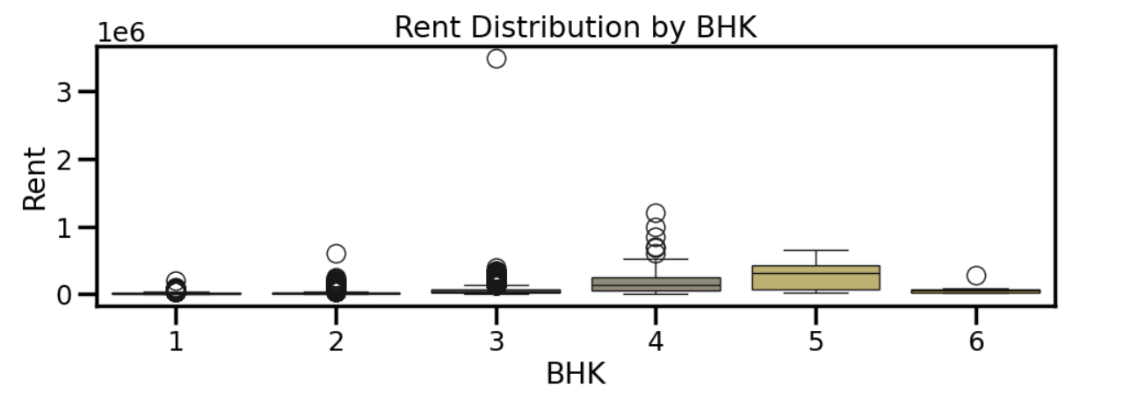

- Rental Price Analysis

- General Description
This objective assesses the correlation among key numeric variables in the dataset, particularly Rent, BHK, and Size. A heatmap is used to identify the strength of these relationships.

- Specific Requirements
• Extract numeric variables from the dataset.
• Calculate Pearson correlation among these features.
• Visualize the results using a heatmap for easy interpretation

- Analysis Results
- Rent is positively correlated with Size (0.41), BHK (0.37), and Bathroom (0.44) — indicating that rent tends to increase with larger and better-equipped units.
- BHK has a strong correlation with Bathroom (0.79) and Size (0.72) — as expected in typical housing layouts.
- All correlations are positive, but none exceed 0.8 with Rent, suggesting moderate association.
- There is some correlation among independent variables, but it does not indicate severe multicollinearity, which is favorable for predictive modeling.

- Visualization
A correlation heatmap was created using Seaborn with the ‘coolwarm’ color scheme, showing numeric feature interactions.

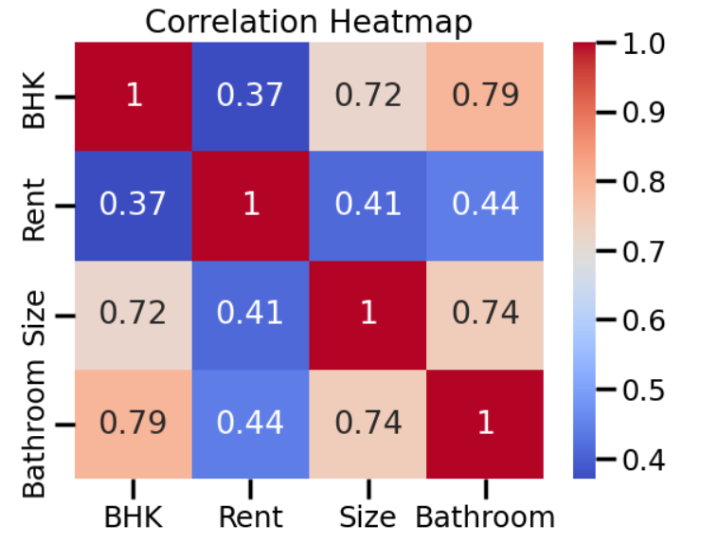

- Count of Furnishing Types by City

- General Description
This objective examines how different furnishing types—Furnished, Semi-Furnished, and Unfurnished—are distributed across various Indian cities, highlighting urban furnishing preferences and availability trends.

- Specific Requirements
• Group data by ‘City’ and ‘Furnishing Status’.
• Count listings for each city-furnishing combination.
• Visualize the distribution using a countplot.

- Analysis Results

- Semi-Furnished properties are the most common across all cities, especially dominant in Bangalore, Chennai, and Mumbai.
- Unfurnished properties are also prominent, particularly in Kolkata, Hyderabad, and Chennai.
- Furnished listings are consistently the least common across all cities, including major metros like Mumbai and Delhi.
- The pattern indicates a general urban preference for semi-furnished units over fully furnished or completely empty spaces.

- Visualization
A Seaborn countplot with a ‘plasma’ palette was used to display furnishing status counts by city.
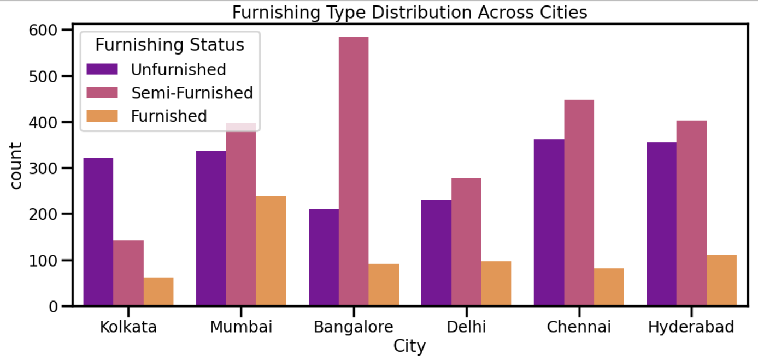

- Monthly Average Rent Trend by Furnishing Status

- General Description
This objective evaluates monthly trends in rental prices across different furnishing statuses—Furnished, Semi-Furnished, and Unfurnished. By aggregating rent data by month, the analysis highlights how furnishing types influence rental price movement over time.

- Specific Requirements
- Convert the ‘Posted On’ column to datetime format
- Group the data by month and furnishing status.
- Compute monthly average rent per furnishing category.
- Visualize the trends using a multi-line plot.

- Analysis Results
- Furnished properties consistently have the highest average rents, with a steep upward trend from April to July.
- Semi-Furnished rentals also show a clear rising trend, maintaining a middle price range between furnished and unfurnished options.
- Unfurnished units have the lowest average rent, although they exhibit a modest increase, especially in July.
- A clear upward trend is seen for all furnishing types, indicating a general rise in rental prices over the months.

- Visualization
A multi-line plot was created to show trends in average rent by furnishing status for each month.

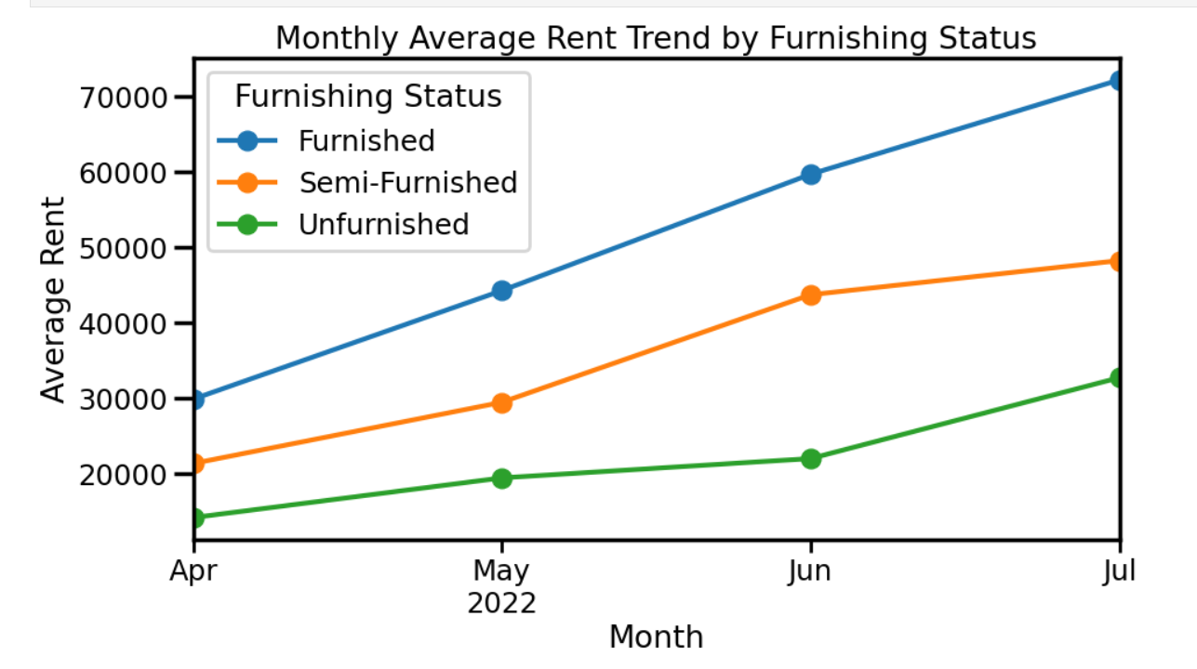

- Furnishing and Tenant Preference Insights

- General Description.
This analysis explores how rental prices vary based on furnishing status (Unfurnished, Semi-Furnished, Furnished) and tenant preference (Bachelors, Family, Both, Company). The goal is to understand how these factors influence rental pricing and identify common rental patterns.

- Specific Requirements
• Group the data by ‘Furnishing Status’ and ‘Tenant Preferred’.
• Calculate and compare average rent values for each group.
• Used violin and bar plots for visual comparisons.
• Used bar charts to compare average rents by tenant type.

- Analysis Results

- Family-preferred listings are the most frequent and generally fall within a moderate rent range.
- Furnished properties are more commonly targeted toward bachelor tenants, possibly indicating convenience or shared accommodations.
- Company-preferred listings (not shown in the current visuals but mentioned) tend to have the highest average rents, likely reflecting corporate leasing standards or included amenities.

- Visualization
• A violin plot displayed rent spread across furnishing types.
• A bar chart visualized average rent by tenant type, showing clear differences in rental patterns.
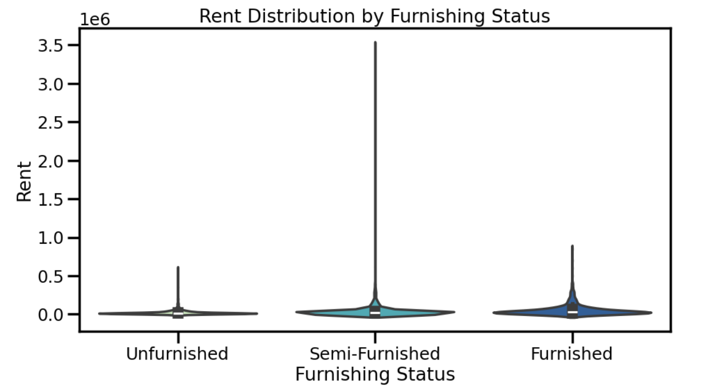

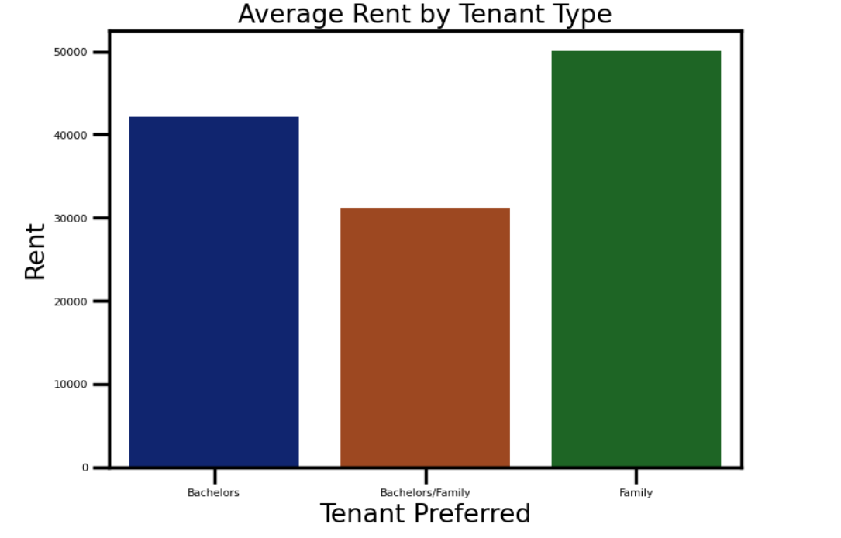

- Scatter Plot on House Rents vs House Sizes

- General Description
This objective visualizes the relationship between house size (in square feet) and rent. A scatter plot helps reveal overall trends, outliers, and how size impacts pricing.

- Specific Requirements
• Plot a scatter graph with Size on the X-axis and Rent on the Y-axis.
• Observe general trends and outlier properties.
• Assess whether size consistently correlates with higher rent.

- Analysis Results

- A positive trend is evident—larger homes generally have higher rents.
- Some large-sized properties show unexpectedly low rents, which may indicate data entry errors or special circumstances (e.g., urgent sales, poor condition).
- A right-skewed pattern appears, where rent spikes disproportionately for certain larger properties, suggesting premium or luxury offerings.

- Visualization
- A scatter plot was used for a straightforward visual representation.
- Numeric axes were kept simple for clarity.
- The plot effectively highlights both the trend and anomalies in the data.
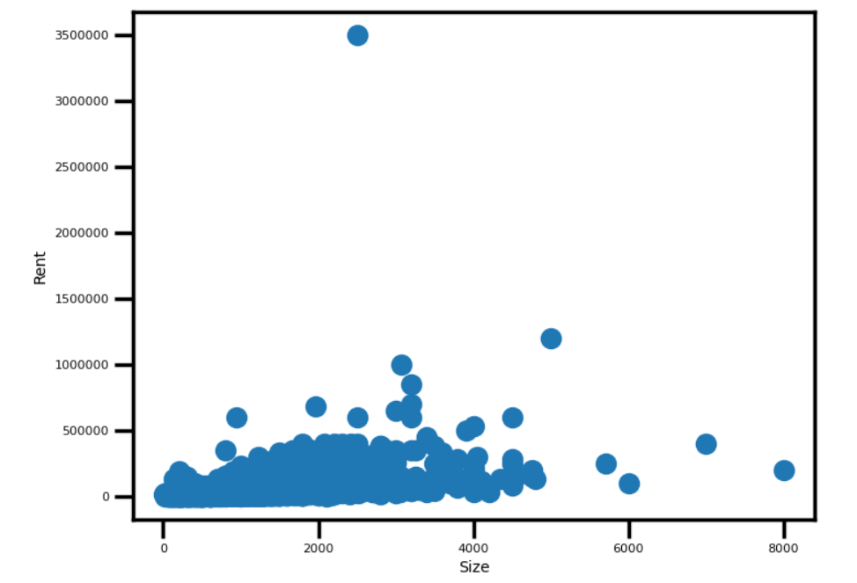

- Distribution of Different Number of BHK Available in the Dataset

- General Description
This objective examines the frequency of different BHK (bedroom) types to understand the most common housing configurations listed in the dataset.

- Specific Requirements
• Use value_counts() to determine the count of each BHK type.
• Visualize the data with a bar chart.
• Emphasized both commonly occurring and rare BHK sizes.

- Analysis Results
• 2BHK units dominate the dataset, indicating strong demand or supply in this segment.
• 1BHK and 3BHK properties also show significant presence, appealing to single professionals or small families.
• The dataset supports a trend toward compact and affordable housing units.

- Visualization
• A bar chart was created using the ‘darkcyan’ color to display BHK frequencies.
• X-axis labels were adjusted and styled for better readability and clarity.
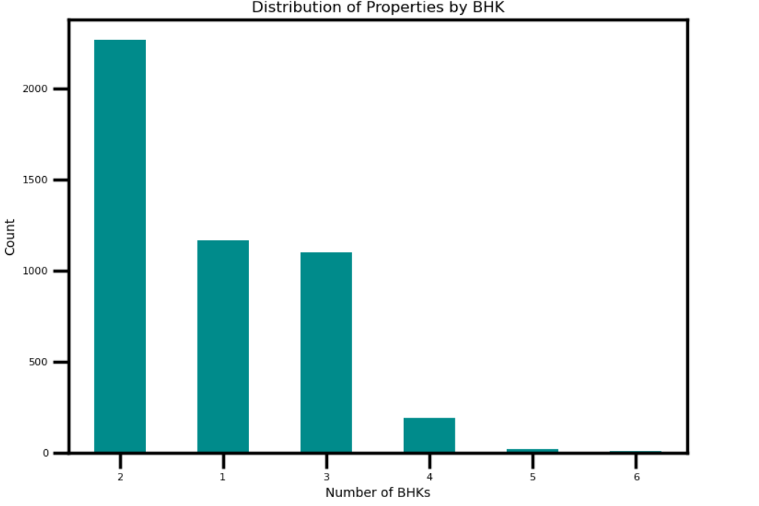

- Conclusion
This exploratory data analysis (EDA) on the Indian rental housing dataset uncovered critical insights into the distribution, pricing trends, and influential factors shaping the rental market across cities and property types. The analysis began with robust data preprocessing—converting date fields, managing categorical variables, and ensuring consistency in numeric values like rent and property size.
A city-wise rent distribution revealed stark affordability disparities, with metropolitan cities such as Mumbai, Delhi, and Bangalore commanding the highest rents. This underlines the role of urbanization, demand concentration, and economic opportunity in driving up housing costs in major metros.
The relationship between BHK count and rent showed a clear upward trend in rent with increasing number of bedrooms. However, the influence of furnishing status and location acted as significant moderators. Notably, 2BHK units emerged as the most common property configuration, aligning with broader trends toward compact and cost-effective housing.
Correlation analysis confirmed a positive association between rent and property size (0.41), number of bathrooms, and BHKs—validating the economic assumption that larger, more feature-rich homes demand higher prices. However, these correlations were moderate, suggesting that multiple factors collectively determine rent rather than a single dominant variable.
Advanced visualizations—boxplots, violin plots, scatter plots, and heatmaps—offered deeper insights into rental dynamics. For instance, furnished homes consistently attracted higher rents, especially among listings targeting bachelors or companies, suggesting that convenience and tenant type significantly affect pricing. Listings open to both bachelors and families showed premium rent levels, indicating the advantage of flexible tenant policies.
A monthly trend analysis of rental prices revealed an overall upward trajectory, especially for furnished and semi-furnished units. These seasonal patterns could help landlords and tenants strategically time postings or lease negotiations.
Distribution plots for furnishing types highlighted the dominance of semi-furnished units, particularly in cities like Bangalore and Chennai. Meanwhile, unfurnished and fully furnished properties remained less prevalent, likely due to differing market segments and affordability considerations.
Overall, this EDA demonstrated how structured data analysis, supported by clear and purposeful visualizations, can unlock actionable insights in real estate. The findings not only highlight existing market dynamics but also pave the way for developing intelligent pricing models, investment strategies, and personalized rental recommendation systems tailored to specific tenant segments and city profiles.

6. Future Scope

The insights derived from this rental price analysis offer a solid foundation for expanding the project into predictive modeling, deeper statistical analysis, and practical real estate applications. The following avenues outline how this work can be extended:

a) Model Extension and Predictive Capabilities
• With a clear understanding of the relationship between factors like city, BHK, size, and furnishing status on rent, predictive models (e.g., linear regression, random forests) can be developed to estimate rent based on property features.
• Machine learning algorithms can be used to predict high-demand zones or rental trends based on time and location data, aiding stakeholders in setting optimal pricing.

b) Statistical Hypothesis Testing
• Differences observed in average rent by tenant preferences or furnishing status can be statistically validated using ANOVA or t-tests.
• Hypotheses like “Furnished homes have significantly higher rent than unfurnished ones” can be formally tested to determine their statistical significance.

c) Expanded Dataset Integration
• Integrating additional data such as neighborhood safety, proximity to public transport, school ratings, or socio-economic indicators would enhance model accuracy and real-world relevance.
• Linking time-series economic data like inflation or interest rates could offer insight into macro-level influences on rental trends.

d) Feature Engineering and Clustering
• Advanced features such as rent per square foot, price elasticity by BHK, or rental yield can be engineered to better assess investment potential.
• Clustering methods like K-Means or DBSCAN can help identify market segments (e.g., luxury vs. budget housing) and tenant clusters based on rental behavior.

e) Real Estate Applications
• The findings can feed into a recommendation engine for rental platforms, helping users find properties based on budget, preferences, and location trends.
• Dashboards can be built for property owners, investors, and policymakers to monitor rent fluctuations and housing demand across cities in real-time.

f) Broader Academic and Industry Impact
• This EDA workflow — from cleaning and visualizing data to drawing insights — can be used as a teaching tool in data science, urban economics, and real estate analytics courses.
• Future projects can explore causal inference (e.g., impact of tenant type on rent) or run A/B tests on different pricing models to inform dynamic pricing strategies for landlords and rental platforms.

7. References

- KAGGLE
- W3Schools
- TutorialsPoint

8. Links

- LinkedIn: https://www.linkedin.com/posts/abhishekkashyap14_datascience-eda-python-activity-7316733877580939264-VlHs?utm_source=share&utm_medium=member_desktop&rcm=ACoAAEfp3S0Ba3IvL0fleFhRRq8j_I2LqrBbOCI
- Github:https://github.com/inabhishek/Comprehensive-Analysis-of-House-Rent

